|  |
| --- |
| , RD Dep.  MTN.*NIX.07 Oracle DB. Introduction to DWH |
| MTN.*NIX.07 Labs - Star Schema Basics |

|  |  |  |  |  |  |
| --- | --- | --- | --- | --- | --- |
| REVISION HISTORY | | | | | |
| Ver. | Description of Change | Author | Date | Approved | |
| Name | Effective Date |
| 1.0 | Initial status of document | [**Kiryl Bucha**](mailto:Kiryl_bucha@epam.com) | 16-JAN-2012 |  |  |
|  |  |  |  |  |  |

*Contents*

# Prerequisites Task

## Passwords Index

## Folder Paths Index

# OLTP – Load External References – Normalization of Data

## Task 01 – Install and expand load of external references T_Languages

**The Main Task** is to running preparing SQL scripts and install needed objects for load external reference T_Languages.

**Task Results:**

* Create sql scripts to show All created Tables and Views – Screenshot

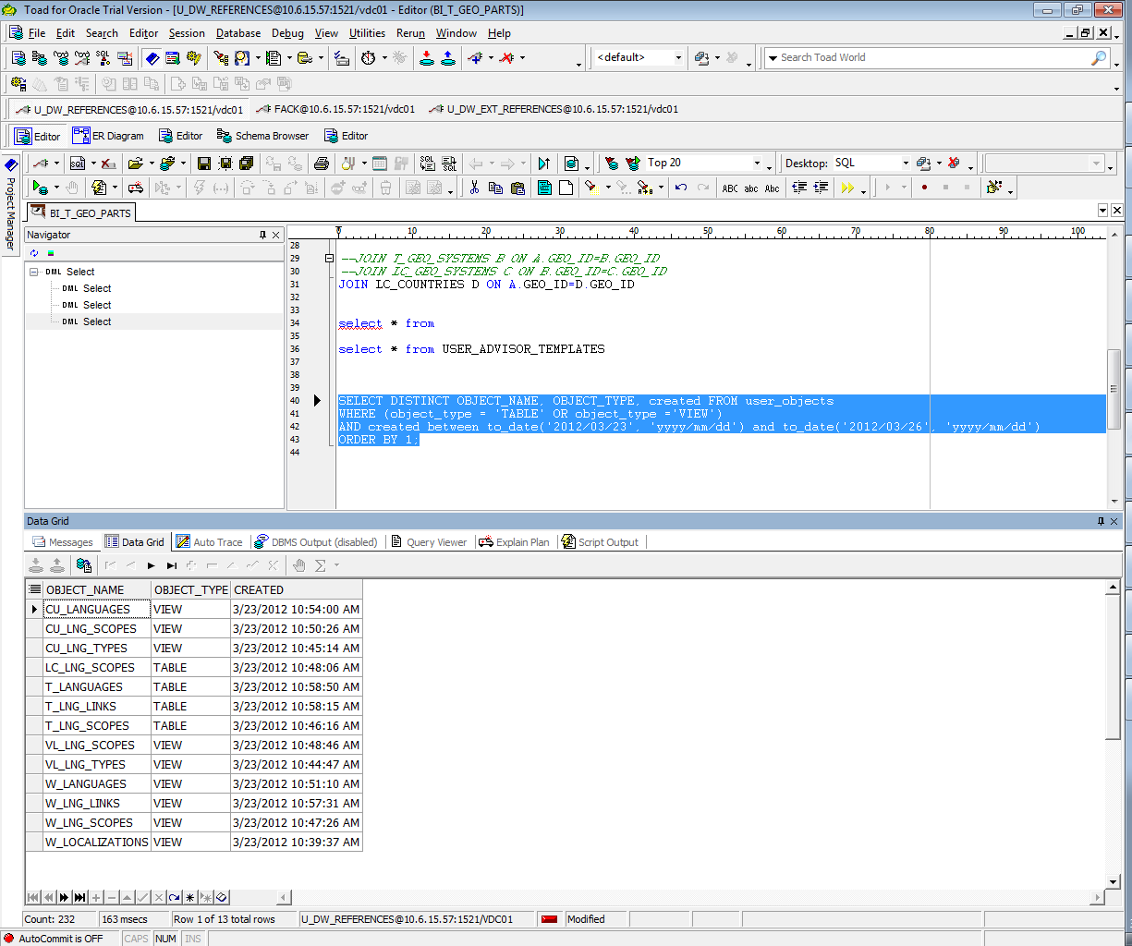

* Create DataFlow: Sketch Diagram of loading external References (MS Visio, MS Paint, MS Word, etc.)
* Create sql: Showing result of data on next objects:
  + t_localizations

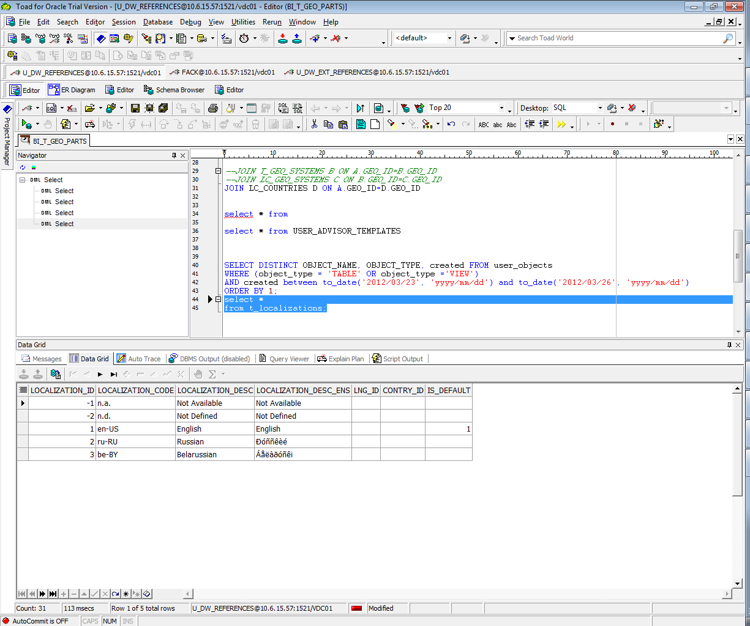

* + cu_languages

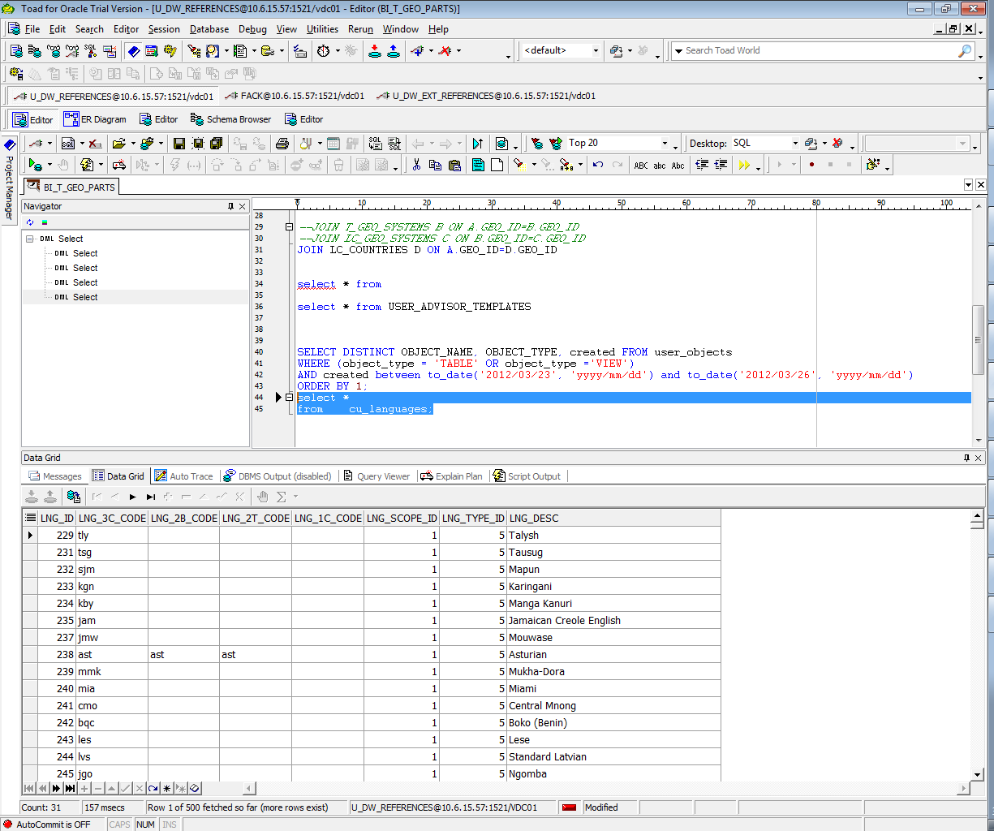

* + w_lng_links

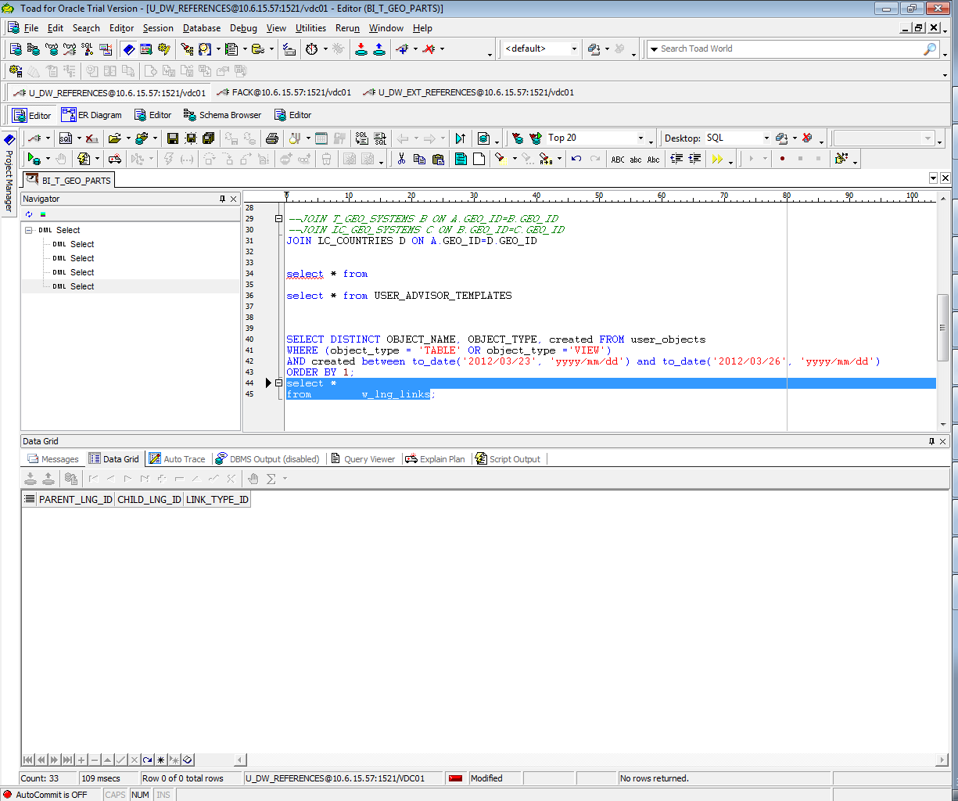

* + cu_lng_scopes

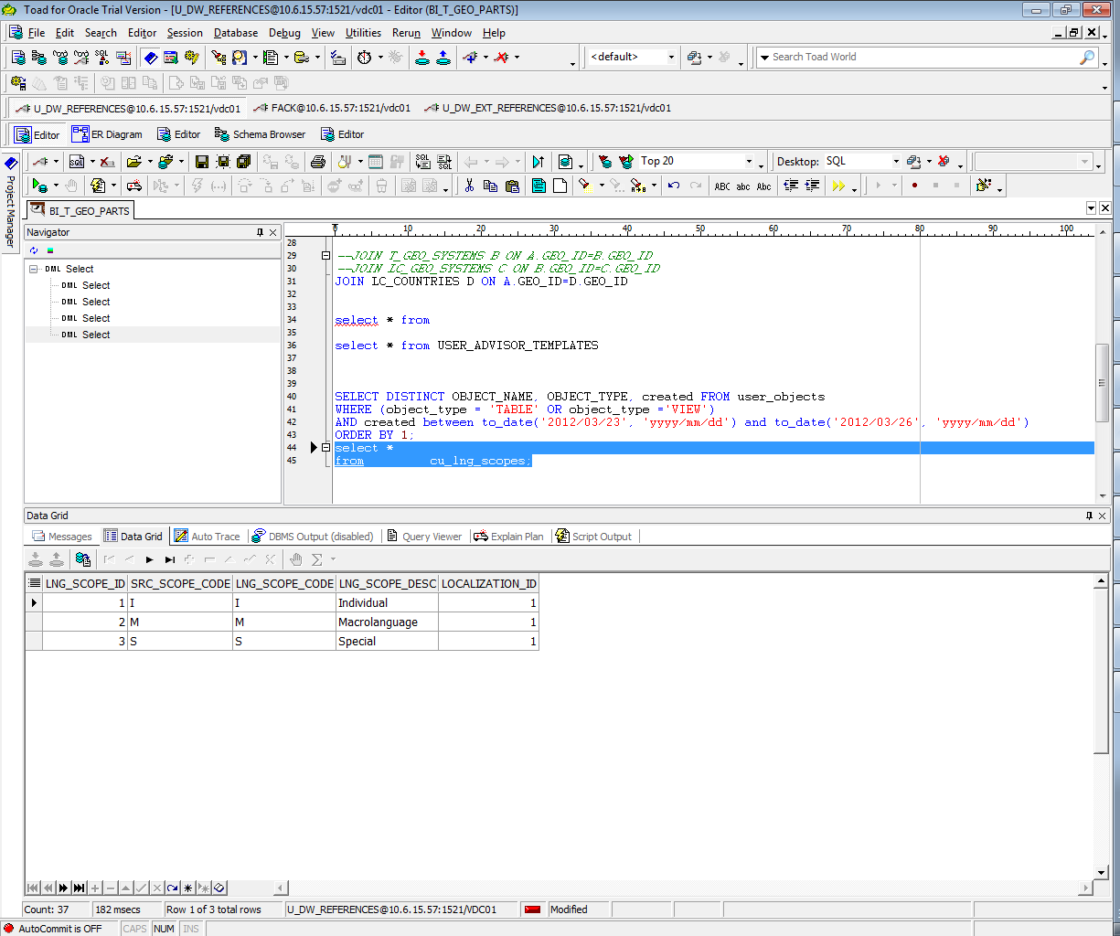

* + cu_lng_types

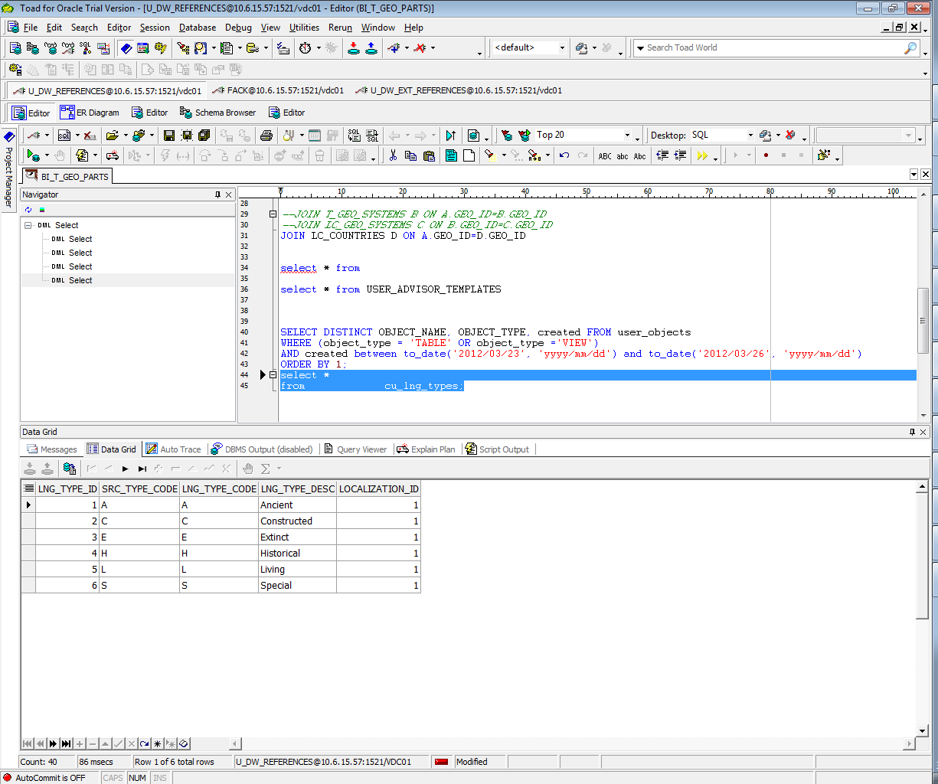

## Task 02 – Create load process for External references T_Countries

**Task Results:**

* Create SQL scripts to show All created Tables and Views – Screenshot

SELECT DISTINCT OBJECT_NAME, OBJECT_TYPE, created FROM user_objects

WHERE (object_type = 'TABLE' OR object_type ='VIEW')

AND created > to_date('2012/03/26', 'yyyy/mm/dd')

ORDER BY 1;

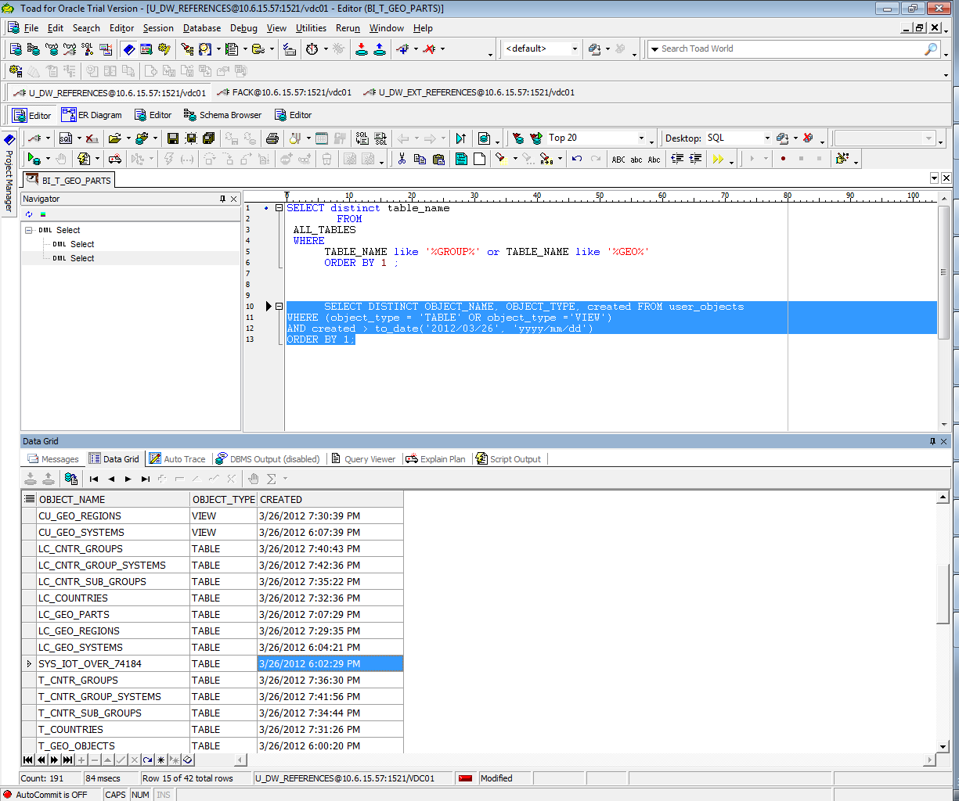

* Create DataFlow: Sketch Diagram of loading external References (MS Visio, MS Paint, MS Word, etc.)
* Create SQL: Showing result of data on main objects:

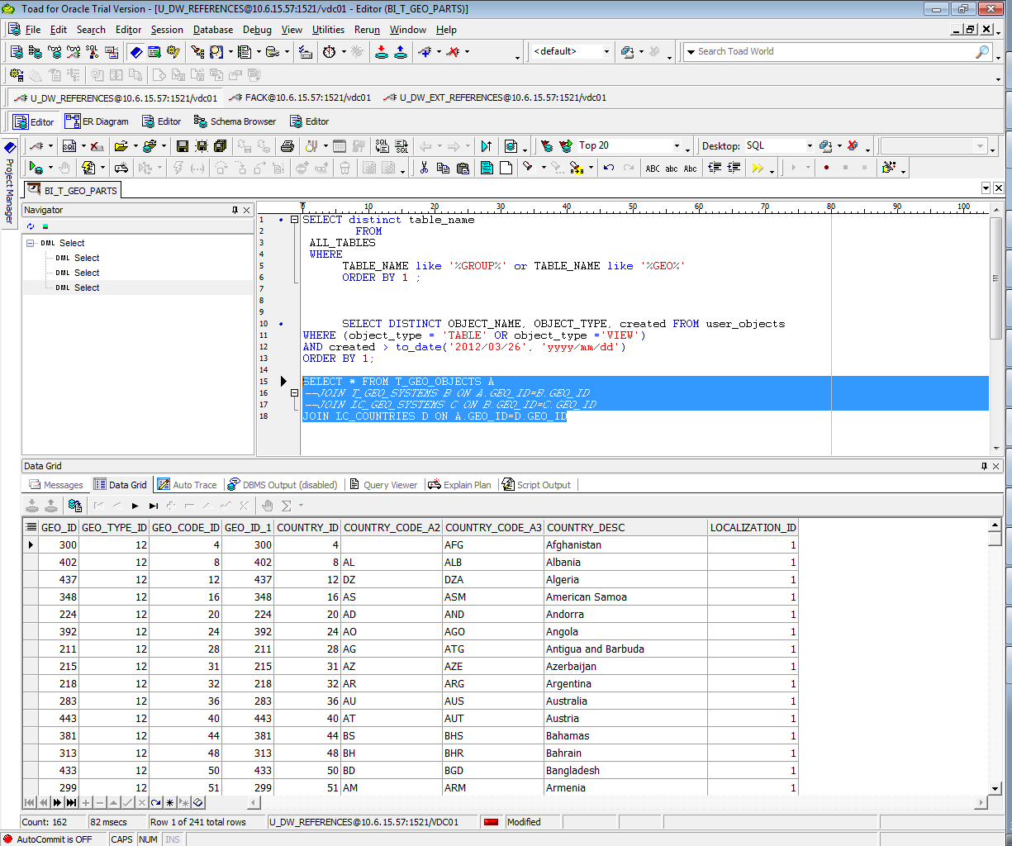

* Prepare T he Physical Diagram of T_Countries 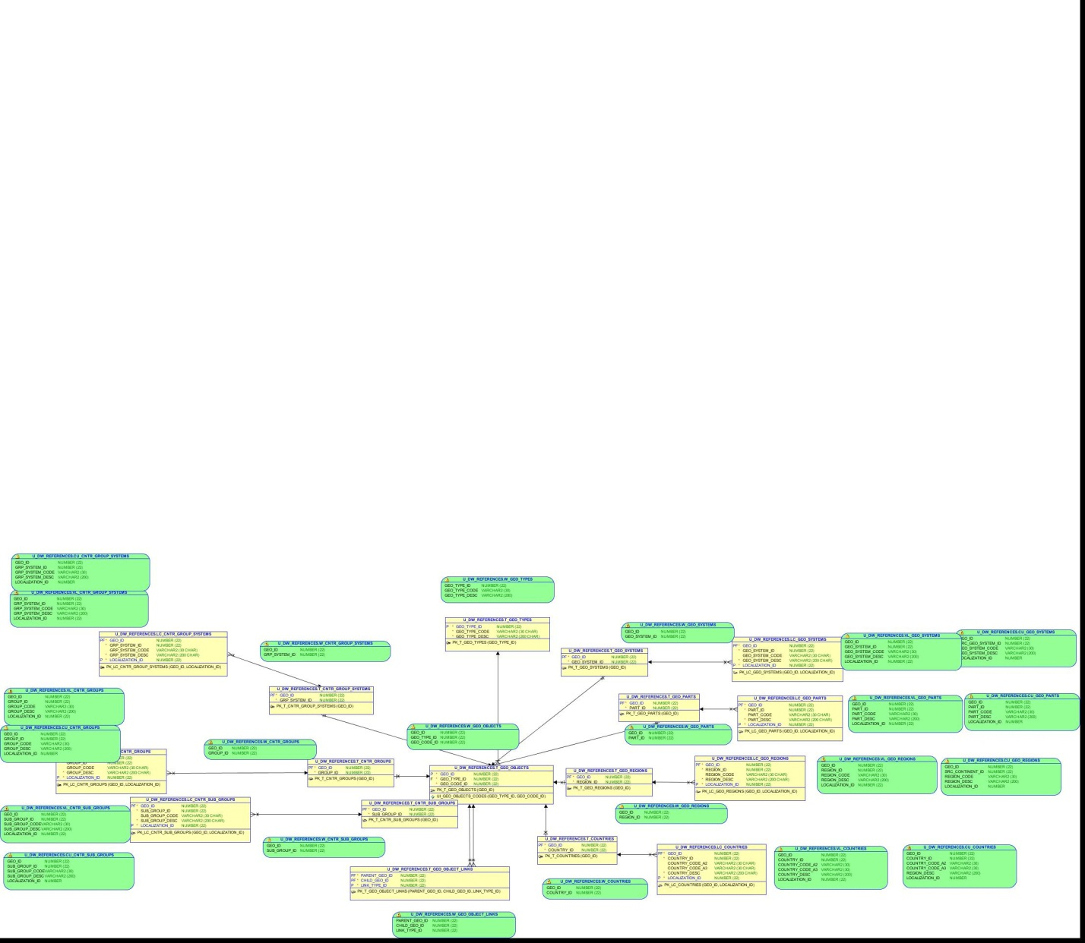

# OLAP – Business analyses task

## Task 03 – Solution concept – Business background

Solution Concept document:

**Overview**

**Business Background**

Our Business is a big chain of stores, witch sales products of apple(mobile phones, computers) and software for the products. Each purchase marks in order. If we want to have a well going business, we need to do the audit and collect static to have possibility see the trends, piks and causes that they have caused.

**Benefit**

BI will help us to collect, transform, keep and analis information about products, customers, stores, orders.

**Requirements**

**Business Requirements**

Business want to know aggregation info about sales. Each sale marks in order, so we need to work with orders. Business need info about count of orders, there sum. Also important information about customers who make orders, there geo locations, gender, age and so on. Very useful would be to know about store’s sales. Ability to view the consistent of order, would give very useful info about well sales good and not very popular, we would be able to we aggregate info in different depends. So, as usual answer – Our customers want to know all possible info about sales in different slices.

The main requirement would to collect all elements that let us to build agrigation data about orders.

They are:

* Products attributes:

- type;

- sub type

- name,

- code,

- type configuration,

- list of technical specifications(display, size and weigt, storage, memory and so on),

- the year of appear,

- price,

- amount of products in store,

- no qualitative,

- country of produce,

- Warranty,

- gists,

"PROD_DESC

"PROD_WEIGHT_CLASS"

"PROD_UNIT_OF_MEASURE"

"PROD_PACK_SIZE"

"PROD_STATUS"

"PROD_VALID"

- Customer attributes:

"CUST_FIRST_NAME"

"CUST_LAST_NAME

"CUST_GENDER"

"CUST_YEAR_OF_BIRTH"

"CUST_MARITAL_STATUS

"CUST_STREET_ADDRESS"

"CUST_POSTAL_CODE"

"CUST_CITY"

"CUST_STATE_PROVINCE"

"CUST_MAIN_PHONE_NUMBER"

"CUST_INCOME_LEVEL"

"CUST_CREDIT_LIMIT"

"CUST_EMAIL"

"CUST_TOTAL"

"CUST_EFF_FROM",

"CUST_EFF_TO"

"CUST_VALID"

* Stores:

Code,

Name,

Location,

Manager,

Date of first open,

Work time of store,

Holidays, weekends,

Rent

And so on.

**Technical Requirements**

Max time for opening report -15s;

Keep info from the beginning of business,

Work time – 24/7/365,

Hardware Requirements.

**Solution Sketch**

**Source Tables structure**

As u can see we have a lot of elements, but we don’t need them all. We have to choose only what we really need.

Summarize Data Plan

U can see it on the diagram:

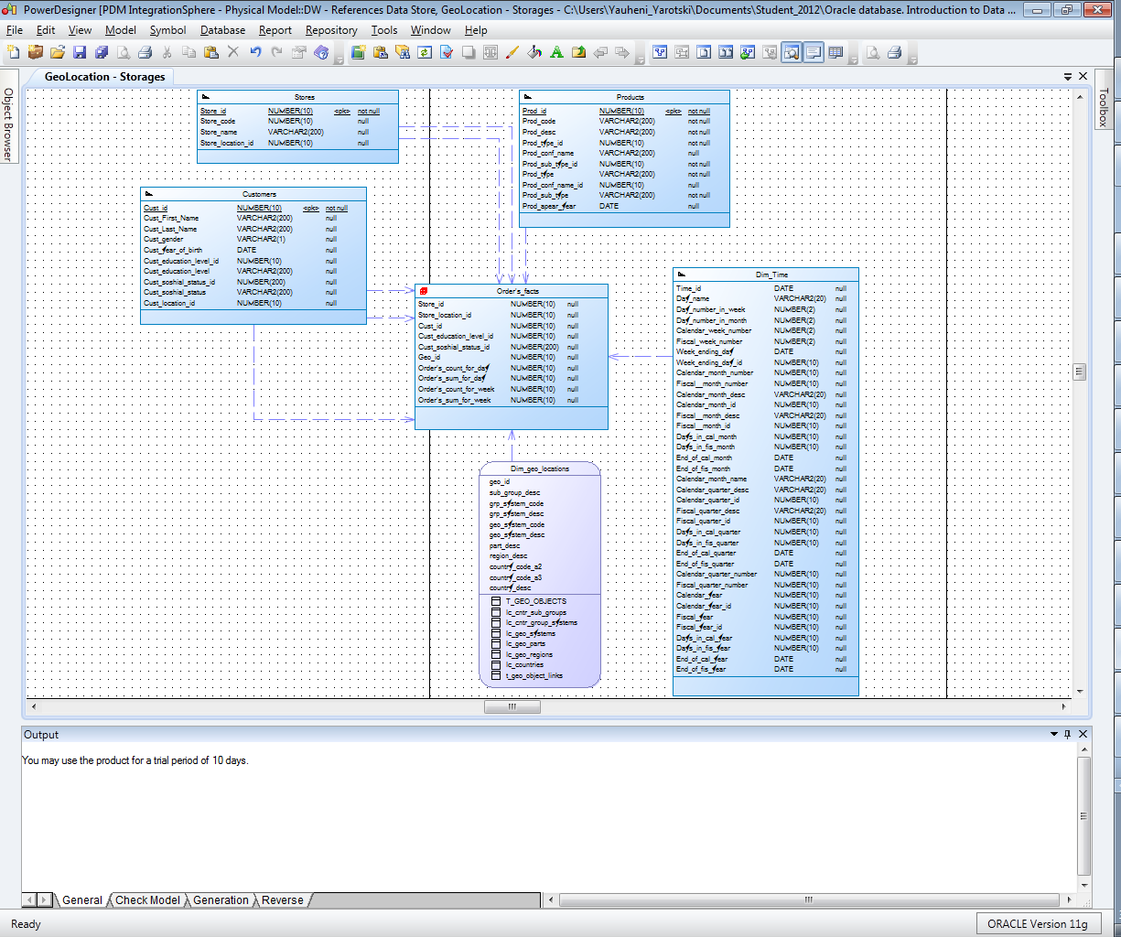

# OLAP – Develop Star-Scheme and SnowFlake Scheme.

## Task 04 – Develop Star-Scheme physical diagram

**The Main Task** is to create Star Physical diagram and Logical diagram of solution.

**Task Results:**

Create document, which contained next chapters:

* + Physical diagram

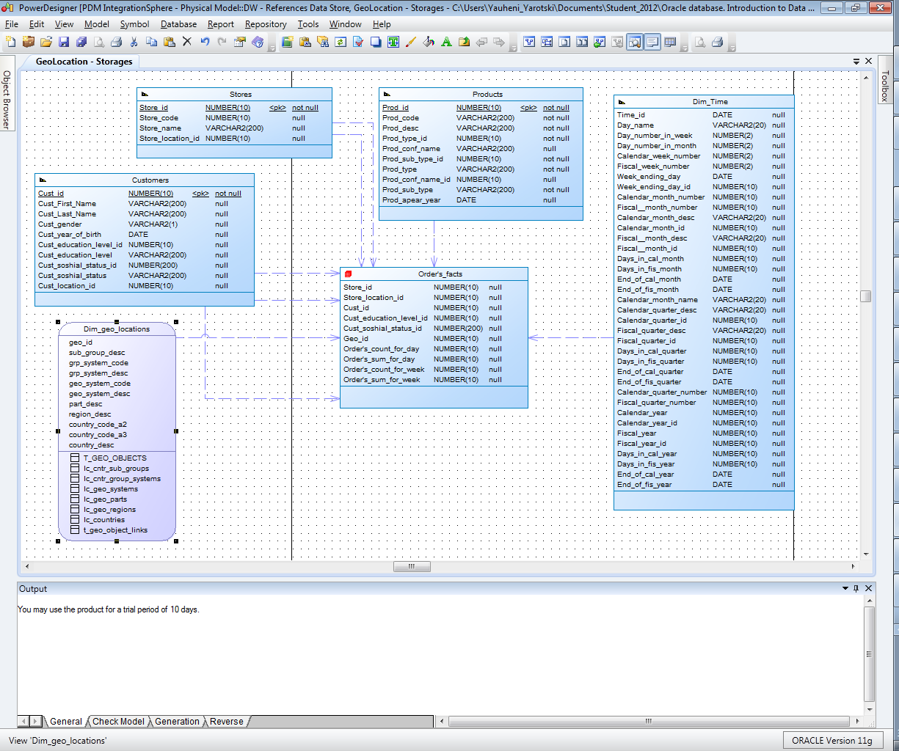

* + Logical diagram
  + 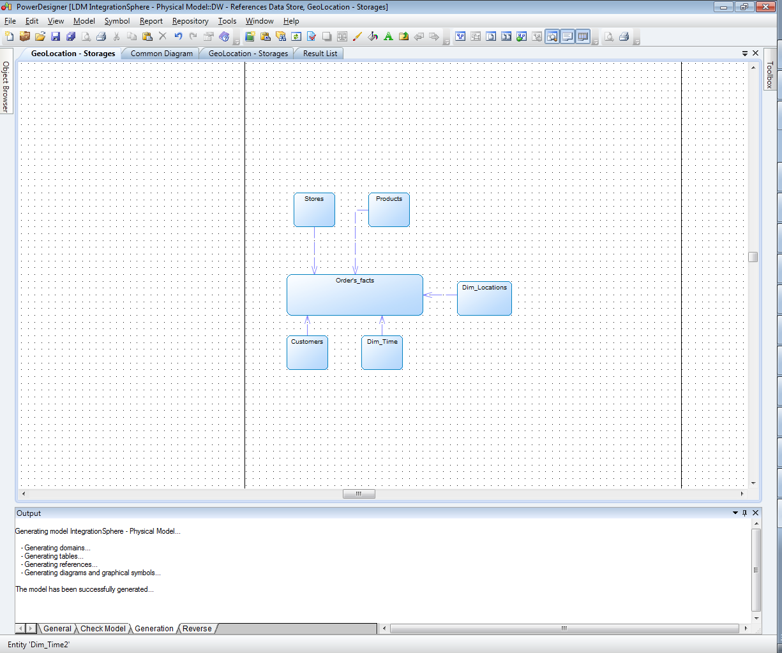

## Task 05 – Develop SnowFlake physical diagram

**The Main Task** is to create SnowFlake Physical diagram and Logical diagram of solution.

**Task Results:**

Create document, which contained next chapters:

* + Physical diagram

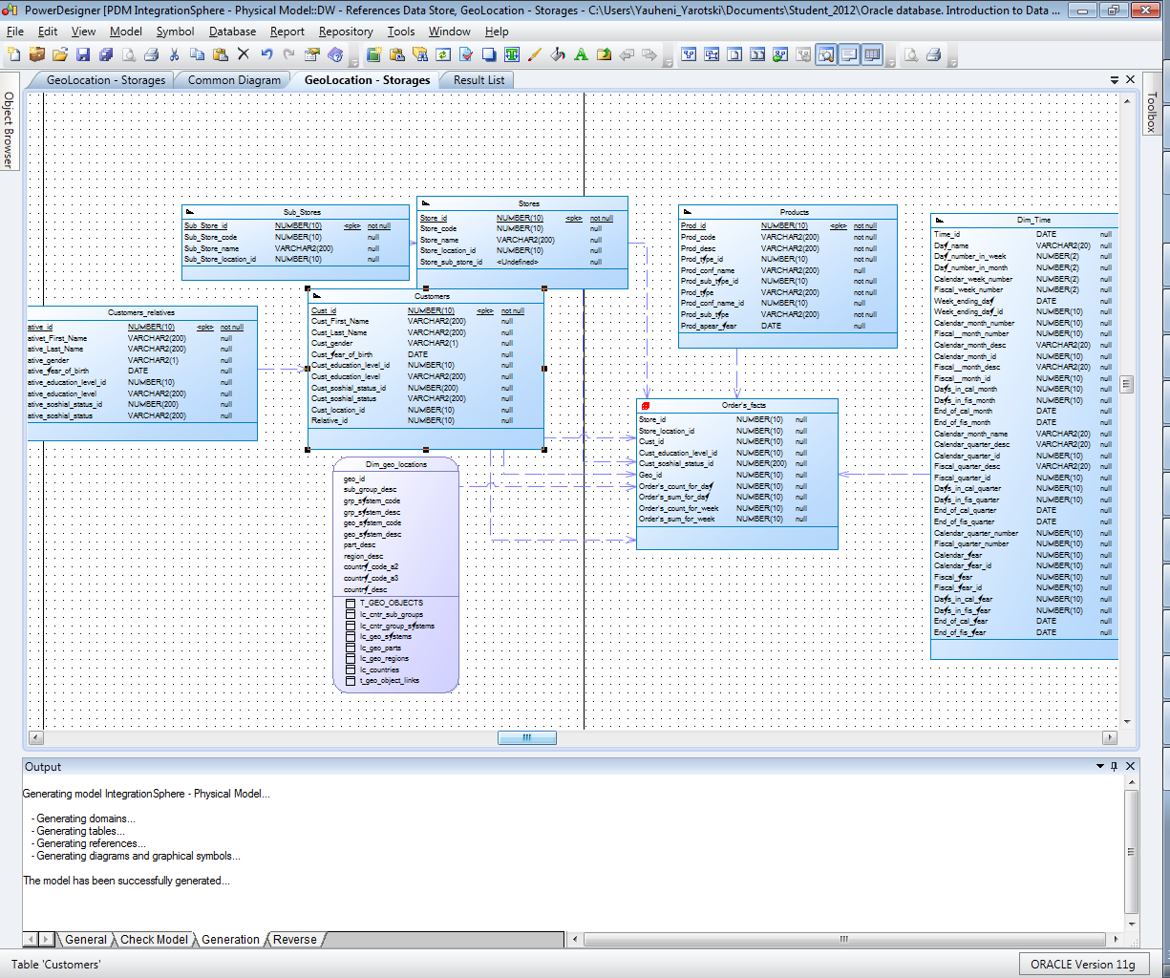

* + Logical diagram

